Cancer cases within the US have increased from 2010 to 2020 due to the mutation of TP53

Kaylea Stover

West Virginia University Institute of Technology

Biology 461

Dr. Mitchell

30 March 2022

INTRODUCTION

Mutations are known as physical changes to DNA and are an important part of evolution. When studying evolution, you must also study mutations and mutation rates, because it is crucial in understanding many other concepts of evolution (Loewe, 2010). Mutation rates can help answer questions about how new species develop and why some go extinct, because it can affect fitness and cause variation (Loewe, 2010). Most mutations have little to no effect, and those that do are usually bad and are probably decreasing fitness at some level. Studying the effects of mutations on population genetics help to uncover some of the reasons why populations change over time, whether it is mutations changing hair color and therefore affecting variation in hair color among that population or affecting the rate of cancer development within a population (Loewe, 2010).

Mutations play a big role in the development of many cancers, mutations to the *KRAS*, *PIK3CA*, *BRAF*, and *TP53* are commonly found to be associated with cancer development; however, the *TP53* gene is more commonly an underlying cause (Mendiratta, 2021). Mutations to the *TP53* gene make up 35% of the mutations that are known to cause cancer (Mendiratta, 2021). Cancer is not caused only by mutations, but data seems to suggest that it plays a large role. Mutation rate of the *TP53* gene appear to be increasing as cancer incidences in the US are increasing.

We cannot assume that the increase in cancer is due completely to *TP53* mutations, or mutations in general, but that it can be related to other factors such as the increase in the population or the increase in obesity, which has been shown to play a role in cancers (Weir, 2015). For example, the increase in the cancer cases of the United States, data collected before 2010, shows that an average of 46.55% of the increase was caused by population growth alone. Using this data Hannah K. Weir, Trevor D. Thompson, Ashwini Soman, Bjorn Moller, and Steven Leadbetter were able to predict the growth or decline in cancer cases from 2010 to 2020 in the US (Weir, 2015). This same paper found that from 1975 to 2009 there was a 137.05% increase in cancer cases, this averages to about 4.03% per year (Weir, 2015).

We will explore the changes in cancer cases from 2010 to 2020 in the US and their correlation with *TP53* mutations, to determine if cancer incidence is still increasing at the same speed or declining and if this result could be related to a correlation between the number of cancer cases and percent relation to *TP53* mutations. Mutation causing cancers in the U.S. relates back to the idea of mutations affecting population genetics, we can also say that it probably has some effect on fitness because it is affecting the life expectancy of many people and may even directly affect reproductive organs causing less offspring to be produced. I hypothesize that cancer cases within the U.S. have increased from 2010 to 2020 and have a positive correlation to *TP53* mutations.

MATERIALS AND METHODS

*Data*

Data for the number of cancer cases for 2010 to 2020 was collected from the paper written by Hannah K. Weir, Trevor D. Thompson, Ashwini Soman, Bjorn Moller, and Steven Leadbetter (Weir, 2015). When writing their paper, they collected their data from the National Cancer Institute’s Surveillance, Epidemiology, and End Results (SEER) program. For their predictions of cancer case changes in the US from 2010 to 2020 they used Nordpred software, which is from the Cancer Registry of Norway website. They also considered changes in population risk, size, and age for more accurate 2020 cancer predications (Weir, 2015). The number of cancer cases for 2010 and the projected cancer cases for 2020 was taken from Table 2 under the “All Races” section of their research paper (Weir, 2015).

The *TP53* mutation rate data was collected from the article titled, *TP53 Mutations in Human Cancers: Origins, Consequences, and Clinical Use*, which was written by Magali Olivier, Monica Hollstein, and Pierre Hainaut (Olivier, 2010). This data can be found on the IARC TP53 Database (Olivier, 2010).

*Analyzing the Data*

Using the data collected, 4 figures were created using RStudio (version 2022.02.1+461). Figure 1 shows the number of cancer cases for several types of cancers for 2010 graphed beside the number of cancer cases for 2020. Figure 1 was created to show any changes in cancer cases that may have occurred within the past 10 years. Figure 3 was created to show the relationship of certain cancers to *TP53* mutations, specifically for 2010. Again, using RStudio, a line plot showing the percent change in cancer cases from 2010 to 2020 among cancers common to both males and females was created. To analyze the relationship between *TP53* mutations and cancer cases, we used the data for 2010. The number of cancer cases reported was plotted against the percent of each cancer affected by *TP53* mutations (Figure 4) and a Pearson’s Correlation test was done on the same data with a 95% confidence interval in RStudio.

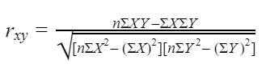

|  |
| --- |
| Equation 1: Correlation Coefficient Formula (Bhandari, 2021). |

RESULTS

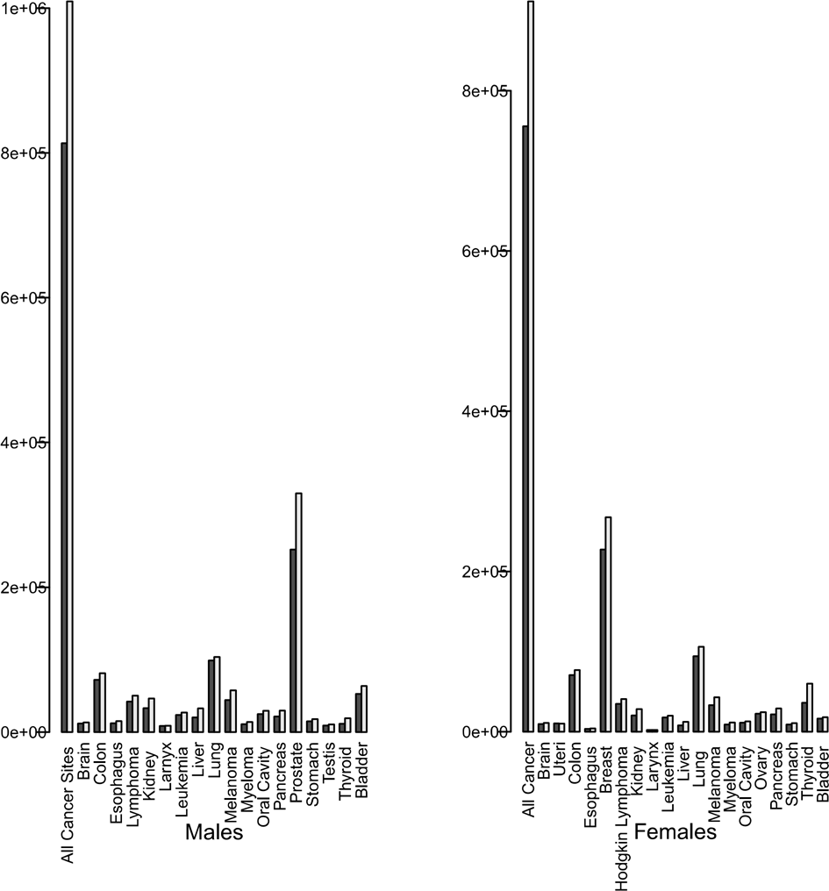

|  |
| --- |
| Figure 1: Number of cancer cases for 2010 is represented in gray, and cancer cases for 2020 is represented in white. |

As we can see most cancers increased within the ten years, while only a few appear to have remained level (Figure 1).

|  |
| --- |
| Figure 2: Percent change for males is represented in orange and females is in green. This graph shows only a few of the cancers that are common among both males and females (cancers not restricted to one sex, such as cancer of the ovaries). |

Cancer cases appear to be increasing for both males and females (Figure 2). If we take the average for each type (for example, the average of percent change in stomach cancer between males and females is 20.05%), then add all the averages together and divide by the number of cancers tested (which was seven in Figure 2), we find that the average percent increase from 2010 to 2020 was 29.21%. This averages to 2.92% increase per year.

|  |
| --- |
| Figure 3: Percent associated with *TP53* mutations was averaged for both males and females, except the bars labeled Ovary, Uteri, and Prostate. It shows the relationship between certain cancers and *TP53* mutations in 2010. |

All cancer types displayed are greater than 10% associated with *TP53* mutations, most are even above 20% relation (Figure 3).

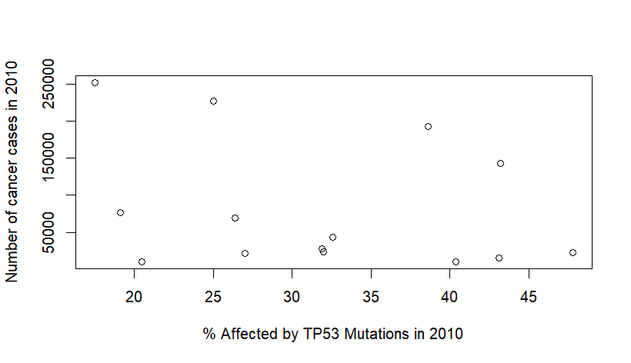

|  |
| --- |
| Figure 4: Each data point is representing a different type of cancer, for example plot (27.0, 21129) is Brain cancer. |

Pearson’s Correlation test was done on the data within Figure 4. We found r =-0.2856649 and p-value = 0.3222.

DISCUSSION

The data show there was an estimated 21.29% increase in cancer cases from 2010-2020 at roughly 2.92% per year. This shows that while cancer cases are still increasing, they are not increasing at the same speed that had occurred from 1975 to 2009, which was an average of 4.03% increase per year. In 2010, it was found that *TP53* mutations occurred in all types of cancers, with the average occurring between 38%-50% (Olivier, 2010). In 2019 it was found that *TP53* mutations occur within an average of 50% of all cancers (Zhang, 2016).

To calculate the percent caused by *TP53* mutation rate for 2010, each cancer percent on the graph was added together than divided by the total number of cancers, the average was found to be 31.79% (Figure 3). This means that an average of 31.79% of cancers are related to *TP53* mutations. As mentioned in 2019 it was found that about 50% of cancers were related to *TP53* mutations (Zhang, 2016). Between 2010 and 2019 there was an 18.21% increase in *TP53* mutations occurring in cancers, which is about 1.82% per year.

Though it appears that there is a positive relationship between *TP53* mutations and the increasing cancer cases from 2010 to 2020, Pearson’ Correlation test revealed that there was a weak negative correlation value (r= -0.2856649) between the number of cancer cases and the percent associated with *TP53* mutations in 2010. The percent of relation to *TP53* mutations and number of cancer cases reported in 2010 had a negative relationship. This probably means that despite both the increase in *TP53* mutations and cancer cases there is not a strong enough correlation to determine that the increase cancer cases are solely related to this specific mutation. It is also possible that this relationship changes between 2010 and 2020. To further investigate this hypothesis, we would need to begin collecting more data for 2020 for another correlation test between the value of increase.

As mentioned, this study of cancer is important when studying evolution (Casás-Selves, 2011). As we know, species evolve through mutations and selection. Cancer tumors also evolve in the same way, though at the species level it is acting upon the individuals and with tumors it is acting upon the cell level. It is more common to find cancer cases among the older generation in the US, which could be indicative of the importance of fitness in youth at the cost of tissue maintenance as we age leading to an increased risk in mutation causing cancers, this is known as antagonistic pleiotropy. This shows that evolution favors better reproductive success over repairing mutated tissues (Casás-Selves, 2011). This could be an alternative explanation for the increased cancer cases within the U.S. due to the aging population, age related cancer data would be necessary to investigate this hypothesis.

ACKNOWLEDGEMENTS

A very special thanks to Dr. Mitchell, who provided the RStudio codes for each figure displayed in this paper.

LITERATURE CITED

Bhandari, P. (2021). Correlation Coefficient | Types, Formulas & Examples. *Scribbr*. [Correlation Coefficient | Types, Formulas & Examples (scribbr.com)](https://www.scribbr.com/statistics/correlation-coefficient/).

Casás-Selves, M., & Degregori, J. (2011). How cancer shapes evolution, and how evolution shapes cancer. *Evolution*, 4(4), 624–634. <https://doi.org/10.1007/s12052-011-0373-y>. )

Loewe, L., & Hill, W. G. (2010). The population genetics of mutations: good, bad and indifferent. *Royal Society*, 365(1544). <https://doi.org/10.1098/rstb.2009.0317>.

Mendiratta, G., Ke, E., Aziz, M., Liarakos, D., Tong, M., & Stites, E. C*.* (2021). Cancer gene mutation frequencies for the U.S. population. *Nat Commun*, 12**(**5961). <https://doi.org/10.1038/s41467-021-26213-y>.

Olivier, M., Hollstein, M., & Hainaut, P. (2010). TP53 mutations in human cancers: origins, consequences, and clinical use. *Cold Spring Harbor perspectives in biology*, 2(1). <https://doi.org/10.1101/cshperspect.a001008>.

Weir, H. K., Thompson, T. D., Soman, A., Møller, B., & Leadbetter, S. (2015). The past, present, and future of cancer incidence in the United States: 1975 through 2020. *Cancer*, 121(11), 1827–1837. <https://doi.org/10.1002/cncr.29258>.

Zhang, Y., Cao, L., Nguyen, D., & Lu, H. (2016). TP53 mutations in epithelial ovarian cancer. *Translational cancer research*, 5(6), 650–663. <https://doi.org/10.21037/tcr.2016.08.40>.